2015 - 2016 RidgeGear Dates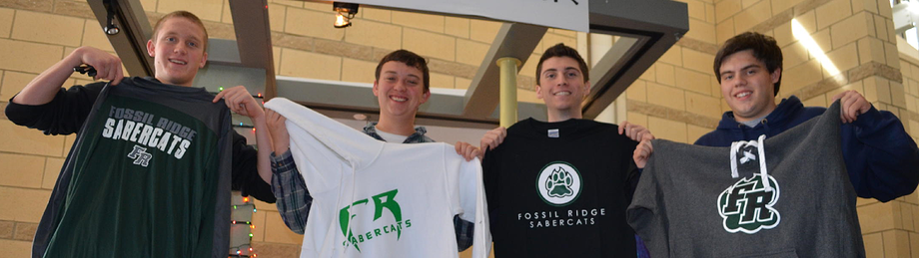

RidgeGear is available to purchase at our kiosk on the dates listed below. You can also order RidgeGear at http://frhsdeca.wix.com/ridgegear

August 10 Senior and Junior Registration (8am - 3pm Commons)
August 11 Sophomore Registration (8am - 3pm Commons)
August 12 Freshmen Registration (8am - 3pm Commons)
August 21 Color Dance (6pm-10pm Courtyard)
August 31 Back-to-School Night (5pm-9pm Commons)
September 22 Home Volleyball Game (5pm - 8pm Gym)
September 29 Home Volleyball Game (5pm - 8pm Gym)
October 6 Parent Teacher Conferences (4pm-8pm Gym)
October 8 Home Volleyball Game (5pm - 8pm Gym)
October 15 Home Volleyball Game (5pm - 8pm Gym)
December Home Boys Basketball Game
December 17 Holiday Sale (1pm - 5pm)
January Home Boys Basketball Game
January 20 Curriculum Fair (4pm-8pm Commons)
February Home Boys Basketball Game
February Home Boys Basketball Game
February 24 Registration Q&A (6pm-8pm PAC)
March 3 Parent Teacher Conferences (4pm-8pm Gym)
May 18 Scholarship Breakfast (6am - 9am Commons)

