Class Penny Order Form
Parent Name:___________________________________________ Cell Phone#____________________
Student Name:______________________________________ Student ID:________________________
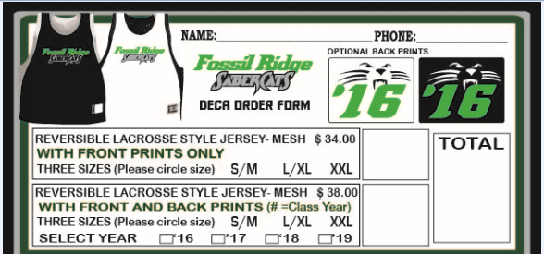
Email:________________________________________________

Class Penny Order Form
Parent Name:___________________________________________ Cell Phone#____________________
Student Name:______________________________________ Student ID:________________________
Email:________________________________________________

